# Office AMS: Apply Branding Console

|  |  |
| --- | --- |
| Summary: | Applies to: |
| This sample shows how branding elements like master pages, page layouts, images and CSS files can be uploaded, published and approved using CSOM. The sample also shows how to change master page for a site.  . | * Office 365 Multi Tenant (MT) * Office 365 Dedicated (D) * SharePoint 2013 on-premises |
| Solution: | Branding.ApplyBranding, version 1.0 |
| Author: | Johan Skårman (Microsoft) |
| //*********************************************************  // THIS CODE IS PROVIDED *AS IS* WITHOUT WARRANTY OF  // ANY KIND, EITHER EXPRESS OR IMPLIED, INCLUDING ANY  // IMPLIED WARRANTIES OF FITNESS FOR A PARTICULAR  // PURPOSE, MERCHANTABILITY, OR NON-INFRINGEMENT.  //********************************************************* | |

# SETUP

To run this sample first set up 2 new site collections (/sites/pub1 & /sites/pub2) with publishing template. Also open settings.xml and change the url in the branding element.

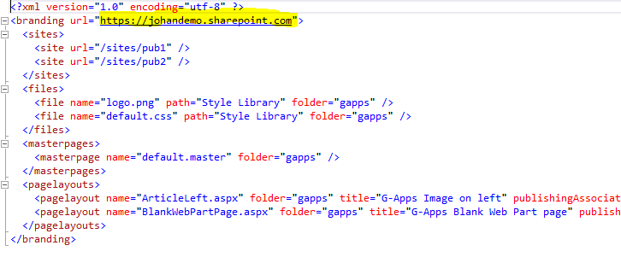

Now you should be able to run the console application with the result below. When prompted for SharePoint Username/Password enter credentials for a user with at least Full Control permission on the sites.

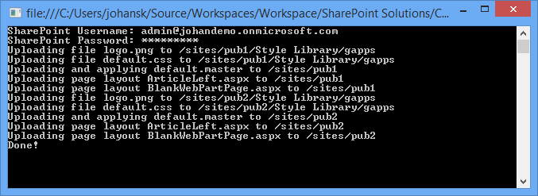

After the application is completed navigate to /sites/pub1 or /sites/pub2 and verify that the branding has been applied. You should also have two new page layouts available.

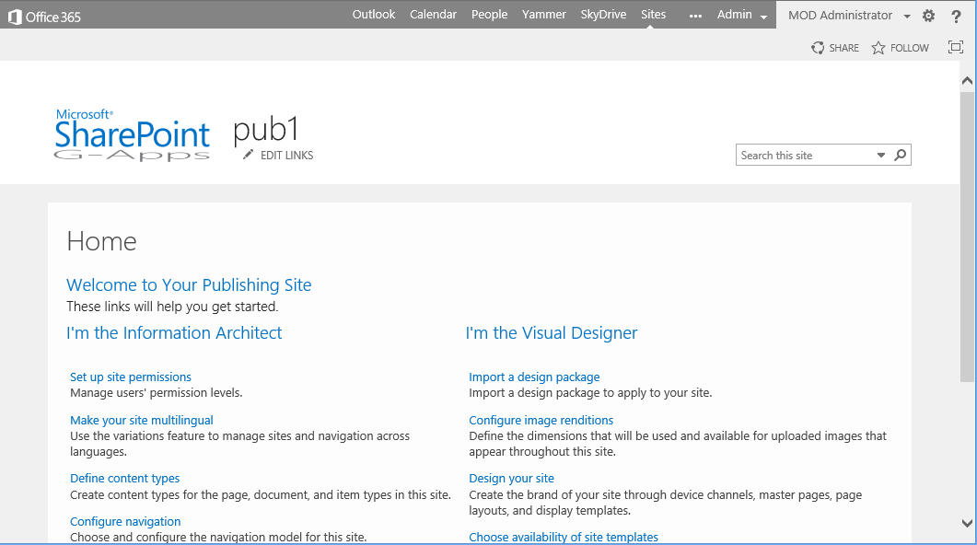

## ADD Aditional ELEMENTS

To add additional elements edit settings.xml, add the file in the corresponding folder (Files, MasterPages or PageLayouts) in solution explorer. Finally set the property Copy to Output Directory to “Copy if newer” on the file so that the file will be available when executing the application.

